Face cabinet factory settings introduction
Edition：FACE_Factory_Settings_V1.0
Date：2018.7.27

1.Lock plate dialing rules
The initial state of the DIP switch is as shown below. Generally, there have three digits can be dialed.
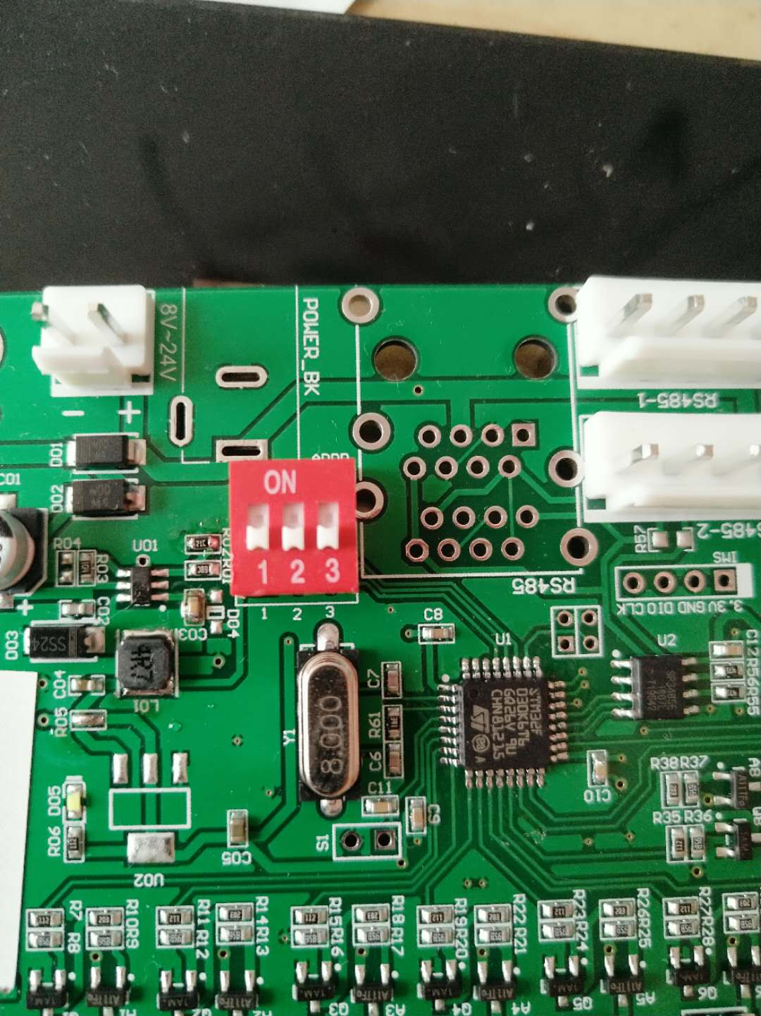
The lock plate number starts at 1，1# lock plate does not dial any code，2# lock plate dial 1,3# lock plate dial2, 4# lock plate dial 3 (or dial 1+2), 5# lock plate dial 1+3, and so on, as shown in the figure below.
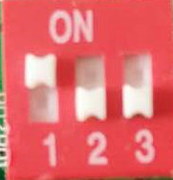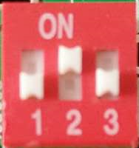
1# lock plate 2# lock plate 3# lock plate

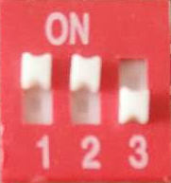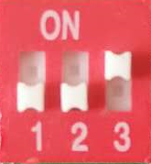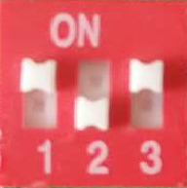
4# lock plate(dial 1+2) 4# lock plate(dial 3) 5# lock plate

2.Factory settings
Press "0" in the "management page" and enter the password 124816 to enter the "factory Settings" page.

2.1 Device function
The face cabinet can be set to work in a random face mode and a fixed face mode. Fixed face mode means that a certain box is fixed for someone.

2.2 Cabinet door number setting
Set the number of doors to which each lock plate is actually connected. When the lock plate number does not exist, set the number of doors to 0. At present, the software supports a maximum of 5 lock plates, and each lock plate can connect up to 12 doors. If you do not meet the requirements, you can contact the modification.
Suppose a cabinet has 30 doors, we need three lock plates, 1# lock plate is connected to 12 doors, 2# lock plate is connected to 12 doors, and 3# lock plate is connected to 6 doors, set as below:

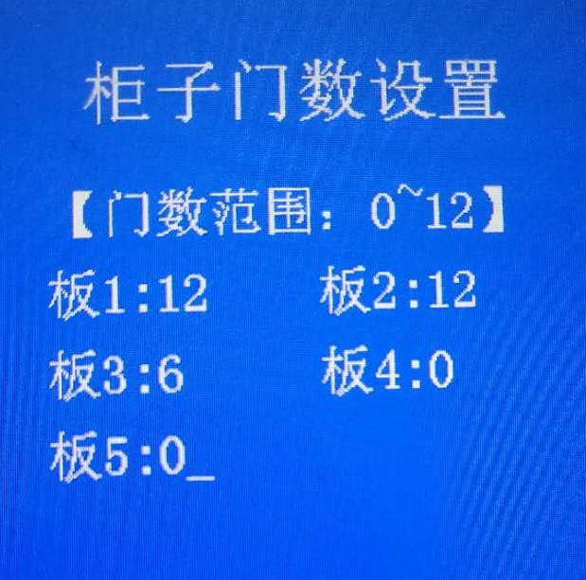

2.3 Cabinet door row number setting
Set the cabinet door arrangement, only set the number of rows, the number of columns is automatically generated. When the number of columns is even, the number of columns on the left and right sides of the first page display area is half of the total number of columns. When the number of columns is odd, the default number of left columns is one less than the number of right columns. When there are too many rows or columns, the door arrangement will not be displayed. If the arrangement is not the default rule, you can contact us to make changes.

2.4 Midway picking function on/off
If the cabinet needs to have a midway pickup function, turn this function on. This option is available in the System Management Administration Page. After this function is turned on, the user will be selected to “take the middle of the object” or “take away all”. If the box is selected “for the middle of the object”, the user can keep using it.

2.5 Size box function on/off
If there are two types of cabinet doors, you can open this function. After opening, you need to set which cabinets are large boxes and which are small boxes. By default, they are all small boxes! Users in storage, also need to choose storage large box or small box.

