# 1.Brief Introduction

Camera

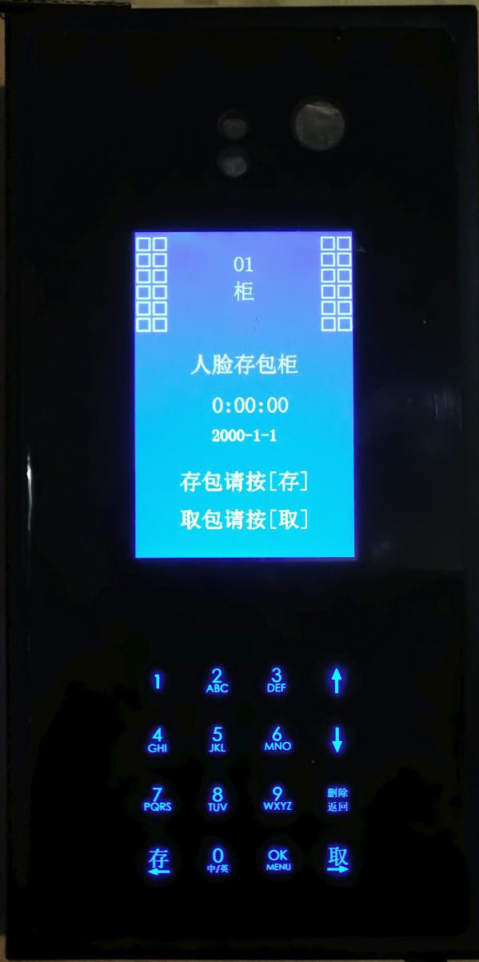

Touch button

Display area

1.Full touch button design with backlight, more beautiful and longer life.

2.Support Chinese and English input for easy administrator management.

3.Two levels of [administrative authority](http://www.baidu.com/link?url=MBj6_8KqDijlD7FIRGlTSAqI6On7nrKsjhaCR5V86TpGl5z2R9OgnC2frPh6i_8LOL-nrs-idEyYZDEO5Afmgr-svIJaCHf1m_k_R_VP7W93rVnyw-52xrPF8bfrvnx2" \t "https://www.baidu.com/_blank) and it is convenient for cabinet management.

4.Administrators quantity: at most 8

5.Opening box record ：more than 10,000 pcs

# 2.Interface display

1.The main interface shows the status of the locker number, time, date and box number and operation hints, and the corresponding operation hints when operating.

2.Storage status Sign description ：

|  |  |  |  |
| --- | --- | --- | --- |
| SIGN | Status decription | SIGN | Status decription |
| 空 | Indicates that the box is empty | 满 | Indicates that the box has been used and has customer items. |
| 锁定 | Indicates that the box is in the disabled lock state. | 半空 | The intermediate state indicates that the box has just taken the item and will automatically go empty after a few seconds. |

# 3.Access Item Operation

**Operation process**：

**1.Storage operation**

Press “Store”button Waiting for the face to collect successfully The door opens automatically Store items Close the door

**2.Take out Operation**

Press “Take”button Waiting for the face to collect successfully The door opens automatically Take out all items Close the door

**Special Note :Keep your expression calm when collecting faces**

# 4.Management Settings Interface

## 4.1. Enter Settings

In the main interface, press the "OK" button for three seconds, switch to the input administrator interface, enter the administrator's face (if registered administrator's face) or password, you can login to the settings interface. Initial use, enter the initial password "888888" and press "OK" to login. After login, please modify the password in time.

## 4.2.Management settings menu introduction

1.Locker number settings

2.Emergency opening box

3.Clear box

4. Lock box number

5.Unlock box number

6. Administrator settings

7.Opening box record

8.Time/Date Settings

9. resume to default settings

10. Factory settings

### 4.2.1 Locker number settings

Set the Locker number ,number range from 0 to 99

### 4.2.2 **Emergency opening box**

You can choose to open one box door or all the box doors, but donot clear box’s storage information,original storage person can still open the corresponding box .

### 4.2.3 **Clear box**

Choose the list box and clear all, clear box operation will open the corresponding box door, at the same time will clear the box's storage information, the original storage person will not be able to open the box.

### 4.2.4 **Lock box number**

The locked box will be disabled until it is unlocked. Locking the box does not clear the original package information.

### 4.2.5 **Unlock box number**

Unlock the original locked box, unlock the box will not clear the original storage information.

### 4.2.6 **Administrator settings**

**1.Modify the initial password**

Modify the system default login password.

1. **Advanced authority Face Registration**

Register the face with advanced authority. This face authority can be

logged into the management interface for all operations.

**3.Ordinary authority Face registration**

Register the face with ordinary authority,it allows to open box,clear box,lock box

and unlock box number opeartion.

**4.Delete administrator**

**5.Query Administrator**

**6.storage time limit setting**

You can set the time limit for accessing items, there is no time limit by default. When the time limit is set and the time limit is exceeded, a box item is not taken away,the box will be in lock status. The customer can't operate any more. It needs the administrator to cancel the lock to continue the operation.

**7.Voice settings**

Turn off, turn on voice, and set voice volume.

### 4.2.7 Opening box record

Can query and delete opening box record.

### 4.2.8 Time/Date settings

The system date and time can be adjusted.

### 4.2.9 **Resume to default settings**

This will clear all records and restore the system to the factory default state, the login password will also be restored to "888888"

### 4.2.10 Factory settings

This is the parameter configuration before leaving the factory, it is not open to users, users do not need to care.